Assignment 7
Rollback and Commit commands Create Teacher table with the following fields (Name, DeptNo, Date of joining, DeptName, Location, Salary)
( a ) Insert five records
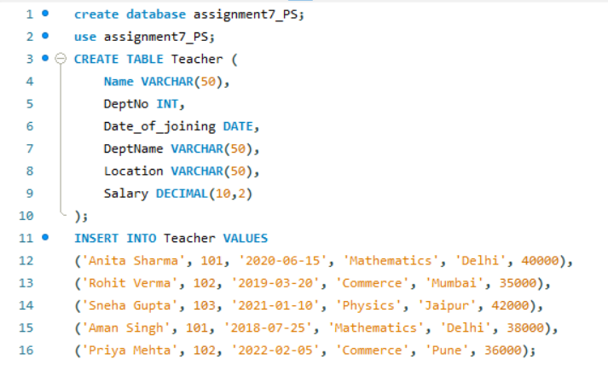
( b ) Give Increment of 25% salary for Mathematics Department .
( c ) Perform Rollback command
(d) Give Increment of 15% salary for Commerce Department
( e ) Perform commit command
